DECIMAL TO HEXADECIMAL CONVERSION:

PROGRAM:

#include<stdio.h>

int main() {

long

int decimalNumber,remainder,quotient;

int

i=1,j,temp;

char

hexadecimalNumber[100];

printf("Enter

any decimal number: ");

scanf("%ld",&decimalNumber);

quotient

= decimalNumber;

while(quotient!=0)

{

temp

= quotient % 16;

//To

convert integer into character

if(

temp < 10)

temp =temp + 48; else

temp = temp + 55;

hexadecimalNumber[i++]=

temp;

quotient

= quotient / 16;

}

printf("Equivalent

hexadecimal value of decimal number %d: ",decimalNumber);

for

(j = i -1 ;j> 0;j--)

printf("%c",hexadecimalNumber[j]);

return

0;

}

INPUT & OUTPUT:

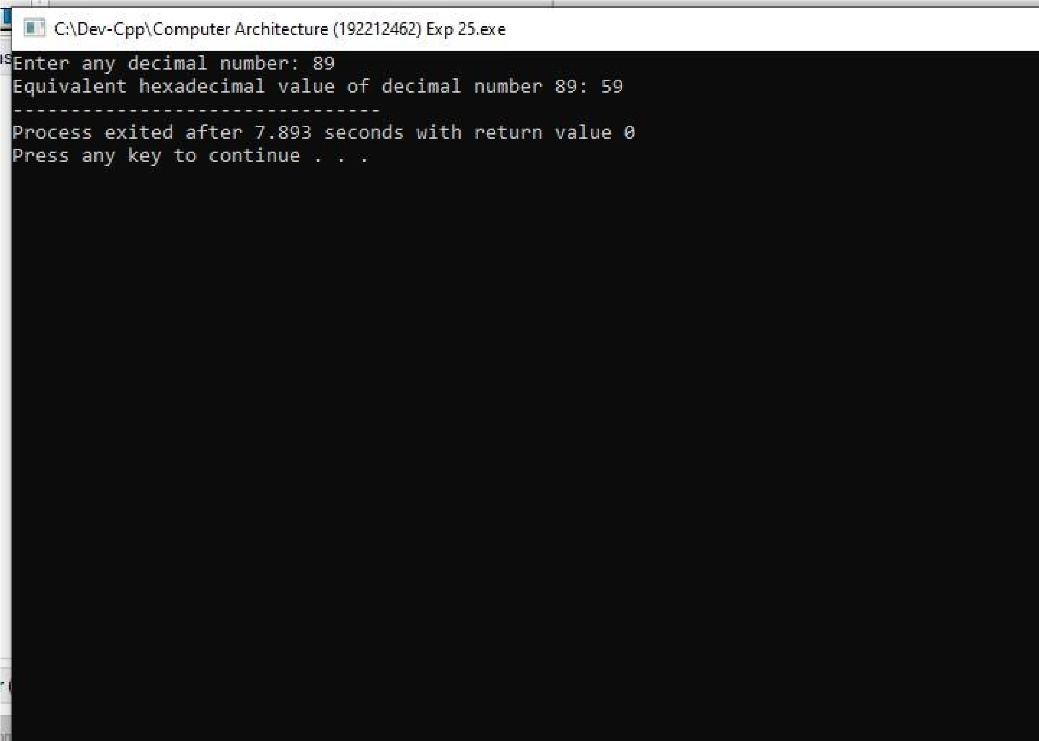

**RESULT:** Thus the program was executed successfully using DevC++.